**To create a Hexagonal Head on a circular rod by using Plain indexing method.**

**Apparatus:**

Milling Machine, Aluminum rod, end mill cutter .

**Theory**

**Indexing Head**

An indexing head, also known as a dividing head or spiral head, is a specialized tool that allows a workpiece to be circularly [indexed](https://wikivisually.com/wiki/Indexing_(motion)); that is, easily and precisely rotated to preset angles or circular divisions. Indexing heads are usually used on the tables of [milling machines](https://wikivisually.com/wiki/Milling_machine), but may be used on many other machine tools including drill presses, grinders, and boring machines. An indexing head, also known as a dividing head or spiral head, is a specialized tool that allows a workpiece to be circularly indexed; that is, easily and precisely rotated to preset angles or circular divisions. Indexing heads are usually used on the tables of milling machines, but may be used on many other machine tools including drill presses, grinders, and boring machines.

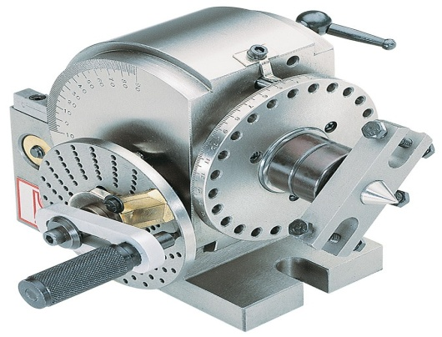

**Index Plates**

Three index plates are furnished with the spiral head, and contain circles with the following numbers of holes:—

|  |  |  |  |  |  |  |
| --- | --- | --- | --- | --- | --- | --- |
| Plate 1— | 15, | 16, | 17, | 18, | 19, | 20. |
| Plate 2— | 21, | 23, | 27, | 29, | 31, | 33. |
| Plate 3— | 37, | 39, | 41, | 43, | 47, | 49. |

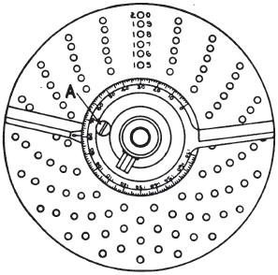

**Procedure**

* To form hexagon head ,divide 40 by 6, which equals 6-1/2 turns
* Give six full turns plus 2/3 of a turn on any circle whose number of holes is divisible by 3. Therefore, 6 full turns of the crank
* Move indexing crank 12 spaces on an 18-hole circle.

**Observations and calculations**

No. of divisions required=N=

No.of Turns of indexing crank=T=40\N

Indexing Plate No. =

Number of holes to be moved =

**Questions**

Define indexing?

_________________________________________________________________________________________________________________________________________________________________________________________________________________________________

What are different methods of indexing?

________________________________________________________________________________________________________________________________

How to perform simple indexing?

________________________________________________________________________________________________________________________________

What is difference between differential and angular indexing?

________________________________________________________________________________________________________________________________________________________________________________________________________________________________

Write the procedure of plain indexing?

______________________________________________________________________________________________________________________________________________________

**Comments:**

How to perform precise cutting? ________________________________________________________________________________________________________________________________